National University of Computer & Emerging Sciences
Karachi Campus



Elevate EDU
Software Requirement Specification
Software Engineering
Section: 6D

Group Members:
23K-0531 Muntaha Adnan
23K-0654 Usaid Sajid
23K-0676 Shaheer Adnan

TABLE OF CONTENTS
Introduction
1.1 Purpose
1.2 Document Conventions
1.3 Intended Audience and Reading Suggestions
1.4 Product Scope
1.5 References

Overall Description
2.1 Product Perspective
2.2 Product Functions
2.3 User Classes and Characteristics
2.4 Operating Environment
2.5 Design and Implementation Constraints
2.6 User Documentation
2.7 Assumptions and Dependencies

External Interface Requirements
3.1 User Interfaces
3.2 Hardware Interfaces
3.3 Software Interfaces
3.4 Communications Interfaces

System Features
4.1 Risk Monitoring and Alert Generation
4.1.1 Description
4.1.2 Stimulus/Response Sequences
4.1.3 Functional Requirements
4.2 Student Analytics, Reports, and Configuration
4.2.1 Description
4.2.2 Stimulus/Response Sequences
4.2.3 Functional Requirements

Other Nonfunctional Requirements
5.1 Performance Requirements
5.2 Safety Requirements
5.3 Security Requirements
5.4 Software Quality Attributes
5.5 Business Rules

Other Requirements
Appendix A: Glossary
Appendix B: Analysis Models
Appendix C: To Be Determined List
1. Introduction

1.1 Purpose
This SRS defines the requirements for ElevateEDU, an AI-powered student risk monitoring and intervention system built for the Spring 2026 Software Engineering project at FAST-NUCES Karachi. The product analyzes attendance, quiz scores, assignment submissions, and performance trends to identify at-risk students and surface actionable recommendations for educators.

1.2 Document Conventions
This document follows the IEEE SRS structure used in the template. Requirement identifiers use the REQ-n convention, headings are organized by section number, and project-specific terms are written in plain language for readability. A monospaced font is used for code, configuration values, and route names when needed.

1.3 Intended Audience and Reading Suggestions
Primary readers are the project evaluators, instructors, developers, and team members who will build or assess the system. Testers and future maintainers can also use this document to understand the expected behavior, design-pattern choices, and deployment assumptions.

1.4 Product Scope
ElevateEDU helps educators detect student risk earlier by consolidating academic signals into a single dashboard, generating alerts when thresholds are crossed, and recommending interventions. The project also demonstrates maintainable software design through Observer, Strategy, Factory, Singleton, and MVC patterns.

1.5 References
References include the project brief in Project Description SE Spring 2026.pdf, the implementation overview document, the FastAPI documentation, SQLAlchemy documentation, Chart.js documentation, and Ollama references for optional AI backends.

2. Overall Description

2.1 Product Perspective
ElevateEDU is a web-based prototype that replaces a monolithic student monitoring workflow with a modular architecture. The application stores data in SQLite, serves pages through FastAPI and Jinja2, and isolates AI behavior behind a strategy interface so the underlying model can change without rewriting the rest of the system.

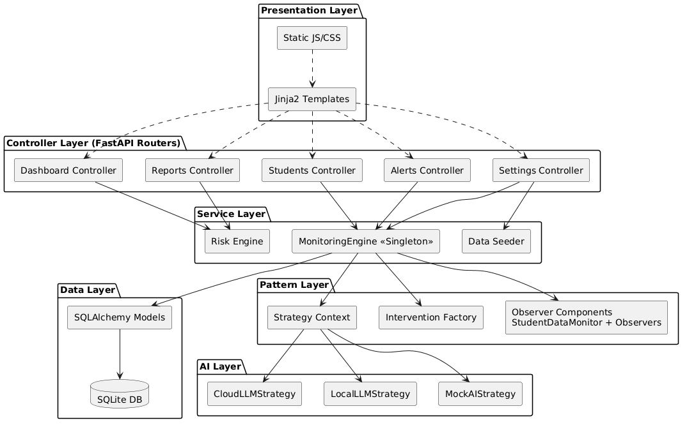

2.2 Product Functions
Major product functions include student data monitoring, risk scoring, alert generation, intervention tracking, dashboard visualization, report generation, AI strategy selection, threshold configuration, and synthetic data reseeding for demos.

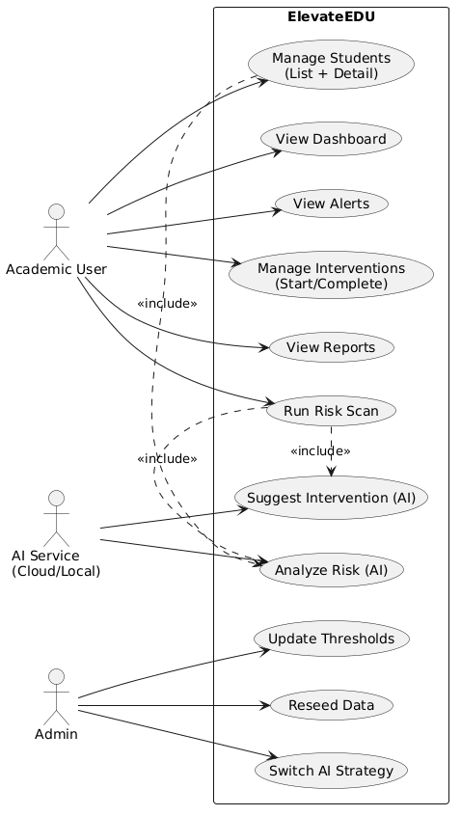

2.3 User Classes and Characteristics
The primary users are educators, academic advisors, and project evaluators. Developers and maintainers are secondary users because they may inspect the architecture, change AI strategy behavior, or extend the data model. Students are indirect stakeholders because the system models their academic risk.

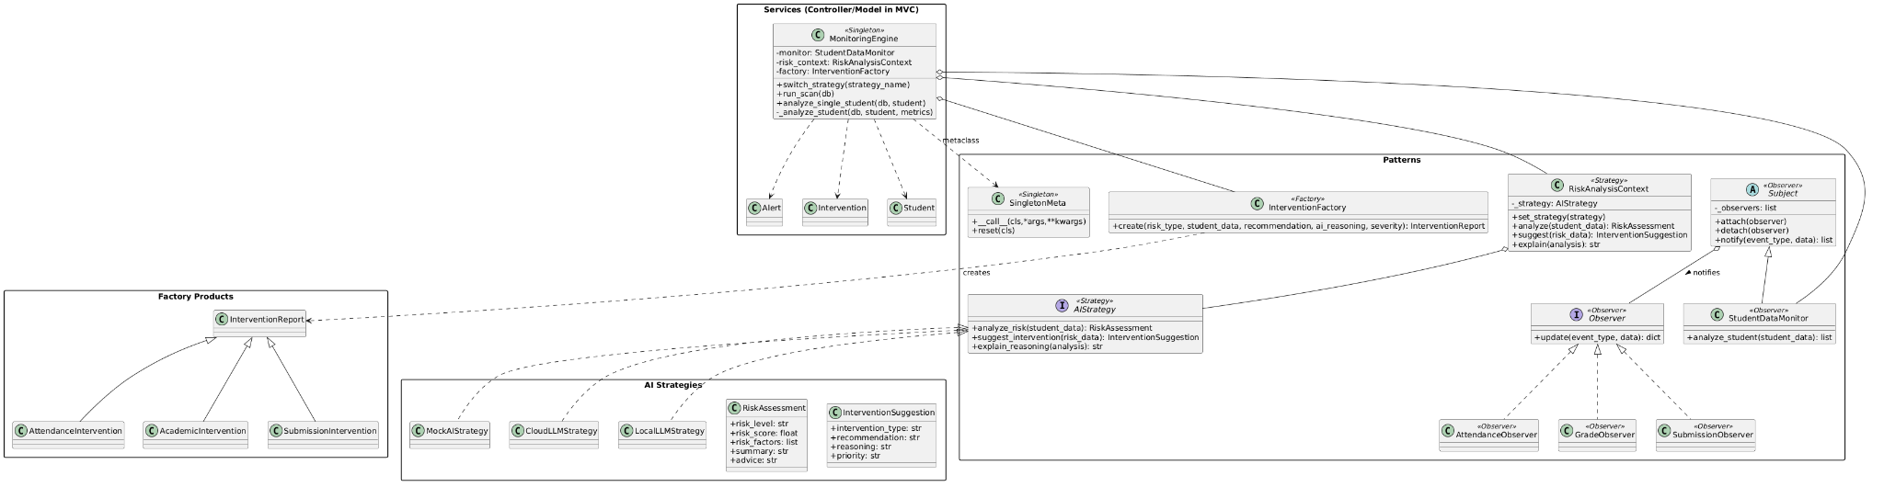

2.4 Operating Environment
The system runs on Windows in a local Python 3.13 virtual environment and is accessed through a modern web browser. It uses FastAPI, Jinja2, SQLite, SQLAlchemy, Chart.js, and optional Gemini or Ollama backends depending on the selected AI strategy.

2.5 Design and Implementation Constraints
Constraints include the required use of software engineering design patterns, the IEEE report format, local database storage, and the need to keep the application understandable enough for grading and demonstration. If the cloud AI strategy is selected, an API key is required; if the local strategy is selected, Ollama must be available on localhost.

2.6 User Documentation
User documentation consists of the README setup instructions, the project demo flow, the dashboard and settings screens, and the alert and student detail pages that show how to scan data and interpret risk results.

2.7 Assumptions and Dependencies
The system assumes that sample academic data can be seeded at first run, that the browser has access to the local FastAPI server, and that optional external AI services are reachable only when their corresponding strategy is enabled. It also assumes the SQLite database file remains writable during execution.

3. External Interface Requirements

3.1 User Interfaces
The user interface includes a dashboard for risk summaries, a students page for search and filtering, a student detail page for per-student analysis, an alerts page for scan results and interventions, a reports page for class-wide analytics, and a settings page for AI strategy and threshold changes.

3.2 Hardware Interfaces
No special hardware is required beyond a standard laptop or desktop used for development and grading. The application should operate comfortably on typical classroom hardware with network access only when cloud AI services are enabled.

3.3 Software Interfaces
Software interfaces include the FastAPI backend, Jinja2 templates, SQLite via SQLAlchemy, Chart.js for graphs, and optional AI providers such as Google Gemini or Ollama. The system also interoperates with the browser through standard HTTP requests.

3.4 Communications Interfaces
Communication uses HTTP between the browser and the FastAPI server. When the cloud AI strategy is enabled, the system also communicates with the external provider over HTTPS. When the local strategy is enabled, it communicates with the Ollama service on localhost:11434.

4. System Features
The system features below represent the main services of ElevateEDU: risk monitoring and alert generation, plus analytics and configuration support.

4.1 Risk Monitoring and Alert Generation

4.1.1 Description and Priority
This feature continuously evaluates attendance, quiz, assignment, and trend data to detect students whose academic status is deteriorating. The priority is high because early identification is the main purpose of the system and directly supports intervention decisions.

4.1.2 Stimulus/Response Sequences
When the user triggers a scan from the Alerts page or when the monitoring engine runs during a refresh, the system analyzes every tracked student, computes risk indicators, creates alerts for students who cross thresholds, and links each alert to a suggested intervention.

4.1.3 Functional Requirements
The functional requirements below define the behavior of the risk-monitoring workflow.

Each requirement is written as an observable system behavior and can be validated through the dashboard, alerts list, and student detail views.

REQ-1: The system shall ingest attendance, quiz, assignment, and trend data for each active student and make the latest values available to the monitoring engine.
REQ-2: The system shall calculate a risk score, classify the student into a risk band, and create an alert with a recommended intervention when the configured threshold is exceeded.

4.2 Student Analytics, Reports, and Configuration

4.2.1 Description

Student Analytics provides comprehensive insights into student performance trends, risk metrics over time, and system-generated intervention recommendations. This feature enables Academic Users to track intervention effectiveness and adjust strategies based on historical data and emerging patterns.

4.2.2 Stimulus/Response Sequences

When an Academic User navigates to the Reports page, the system retrieves all stored Intervention and Alert records from the database. The user can apply filters by date range (30-day, 60-day, 90-day periods), risk type (Attendance, Academic, Submission), or student cohort. Upon filter application, the system computes aggregated analytics including mean risk scores, intervention rates, and effectiveness metrics. The system generates interactive visualizations (line charts for trends, bar charts for comparisons, pie charts for risk distribution) and provides downloadable PDF reports containing statistical summaries and recommendations for strategy adjustment.

4.2.3 Functional Requirements

• REQ-4: System shall generate historical risk trend charts (line graphs) showing individual student and cohort-level risk scores over 30-day, 60-day, and 90-day periods for trend analysis.

• REQ-5: System shall provide intervention effectiveness reports comparing student risk levels before intervention initiation and after intervention period completion to quantify intervention impact.

• REQ-6: System shall support export of analytics reports as PDF documents with configurable date ranges, student filters, risk type filters, and include both statistical summaries and visual charts.

• REQ-7: System shall provide configuration interface for Academic Users to adjust intervention thresholds, select AI strategy (Mock, Cloud LLM, or Local LLM), and define intervention types (Attendance-based, Academic-based, Submission-based).

• REQ-8: System shall maintain audit logs of all configuration changes with timestamps and user identifiers for compliance and troubleshooting purposes.

5. Other Nonfunctional Requirements

5.1 Performance Requirements
The application should load the dashboard, students, alerts, reports, and settings pages in a few seconds on a typical classroom laptop. Risk scans for the seeded data set should complete quickly enough for interactive use during a live demo.

5.2 Safety Requirements
The system is not safety-critical, but it should prevent accidental misuse by clearly labeling alerts, showing the reason for each recommendation, and requiring explicit user actions before marking interventions complete.

5.3 Security Requirements
API keys and other secrets should be stored in environment variables rather than in the repository. The application should avoid exposing sensitive student information beyond the authenticated or intended demo context, even though the current project is a classroom prototype.

5.4 Software Quality Attributes
Important quality attributes are maintainability, extensibility, traceability, and explainability. The architecture should make it easy to swap AI engines, add new report views, and trace every alert back to the data that produced it.

5.5 Business Rules
Only users with project-configuration responsibility should change the AI strategy, thresholds, or seeded data. The active strategy should be one of mock, cloud, or local, and threshold updates should take effect without requiring a code change.

6. Other Requirements
Other requirements include a persistent SQLite database, reproducible synthetic student data, clear logging for scan actions, and compatibility with the existing FastAPI route structure used by the application.

Appendix A: Glossary
Term | Definition
Academic User | An educator, instructor, or academic advisor who uses ElevateEDU to monitor student risk, review alerts, and track intervention effectiveness.
Alert | A system-generated notification created when a student's risk score exceeds the configured threshold. Each alert includes a risk classification, severity level, and recommended intervention.
API (Application Programming Interface) | A set of protocols and tools that allow different software components to communicate. In ElevateEDU, the FastAPI backend exposes endpoints for the web interface.
Assessment | Any evaluated academic activity including quizzes, assignments, exams, or projects used to measure student performance.
At-Risk Student | A student whose attendance, academic performance, or submission patterns indicate elevated probability of academic difficulty or course failure.
Chart.js | A JavaScript library used to render interactive visualizations including line charts, bar charts, and pie charts in the reports and dashboard views.
Cloud AI Strategy | An AI strategy implementation that uses external cloud-based language models (e.g., Google Gemini) to generate intervention recommendations via API calls.
Cohort | A group of students tracked together for analytics purposes, typically representing a class section or academic term.
Design Pattern | A reusable solution to a commonly occurring problem in software design. ElevateEDU implements Observer, Strategy, Factory, Singleton, and MVC patterns.
Factory Pattern | A creational design pattern that provides an interface for creating objects without specifying their exact class. Used in ElevateEDU to instantiate AI strategy objects.
FastAPI | A modern Python web framework used to build the backend API and serve HTTP endpoints for the ElevateEDU application.
Intervention | A targeted action or support mechanism recommended by the system to help an at-risk student improve their academic standing (e.g., tutoring referral, academic counseling, study group assignment).
Jinja2 | A templating engine for Python used to render dynamic HTML pages in the ElevateEDU web interface.
Local AI Strategy | An AI strategy implementation that uses a locally hosted language model (via Ollama) to generate recommendations without requiring external network access or API keys.
Mock AI Strategy | A testing-oriented AI strategy that returns predefined, hardcoded recommendations for demonstration and development purposes without calling actual AI models.
MVC (Model-View-Controller) | An architectural pattern that separates application logic (Model), user interface (View), and input handling (Controller). ElevateEDU uses this pattern to organize code.
Observer Pattern | A behavioral design pattern where objects (observers) subscribe to state changes in another object (subject). Used in ElevateEDU for monitoring student data changes.
Ollama | An open-source tool for running large language models locally. Used by the Local AI Strategy when generating intervention recommendations offline.
REQ (Requirement) | A requirement identifier using the format REQ-n where n is a unique number. Used throughout the SRS to tag specific functional requirements.
Risk Band | A categorical classification of student risk level (e.g., Low, Medium, High, Critical) determined by comparing the calculated risk score against configured thresholds.
Risk Score | A numerical value (typically 0-100) representing the severity of a student's academic risk based on attendance, quiz performance, assignment submissions, and performance trends.
Scan | The process of analyzing all student records, calculating risk scores, generating alerts for students exceeding thresholds, and recommending interventions.
Singleton Pattern | A creational design pattern that ensures a class has only one instance and provides global access to it. Used in ElevateEDU for configuration and database connection management.
SQLAlchemy | A Python SQL toolkit and Object-Relational Mapping (ORM) library used to interact with the SQLite database in an object-oriented manner.
SQLite | A lightweight, file-based relational database engine used to store student data, alerts, interventions, and configuration settings.
SRS (Software Requirements Specification) | A document that describes the intended purpose, features, and constraints of a software system. This document is the SRS for ElevateEDU.
Strategy Pattern | A behavioral design pattern that defines a family of algorithms, encapsulates each one, and makes them interchangeable. Used in ElevateEDU to allow runtime selection between Mock, Cloud, and Local AI strategies.
Synthetic Data | Artificially generated student records and assessment data used for testing and demonstration purposes. ElevateEDU seeds synthetic data at initialization for classroom demos.
Threshold | A configurable numerical boundary that triggers alert generation when a student's risk score exceeds it. Different thresholds can be set for attendance, academic performance, and submission patterns.
Trend Analysis | The examination of student performance patterns over time to identify improving, stable, or declining academic trajectories.

Appendix B: Analysis Models
Analysis models expected for the report include a use case diagram, class diagram, sequence diagrams for scanning and intervention flows, and an entity-relationship view of the student and assessment data.

B.1 Use Case Diagram


B.2 Class Diagram


B.3 Component Diagram


B.4 Sequence Diagrams
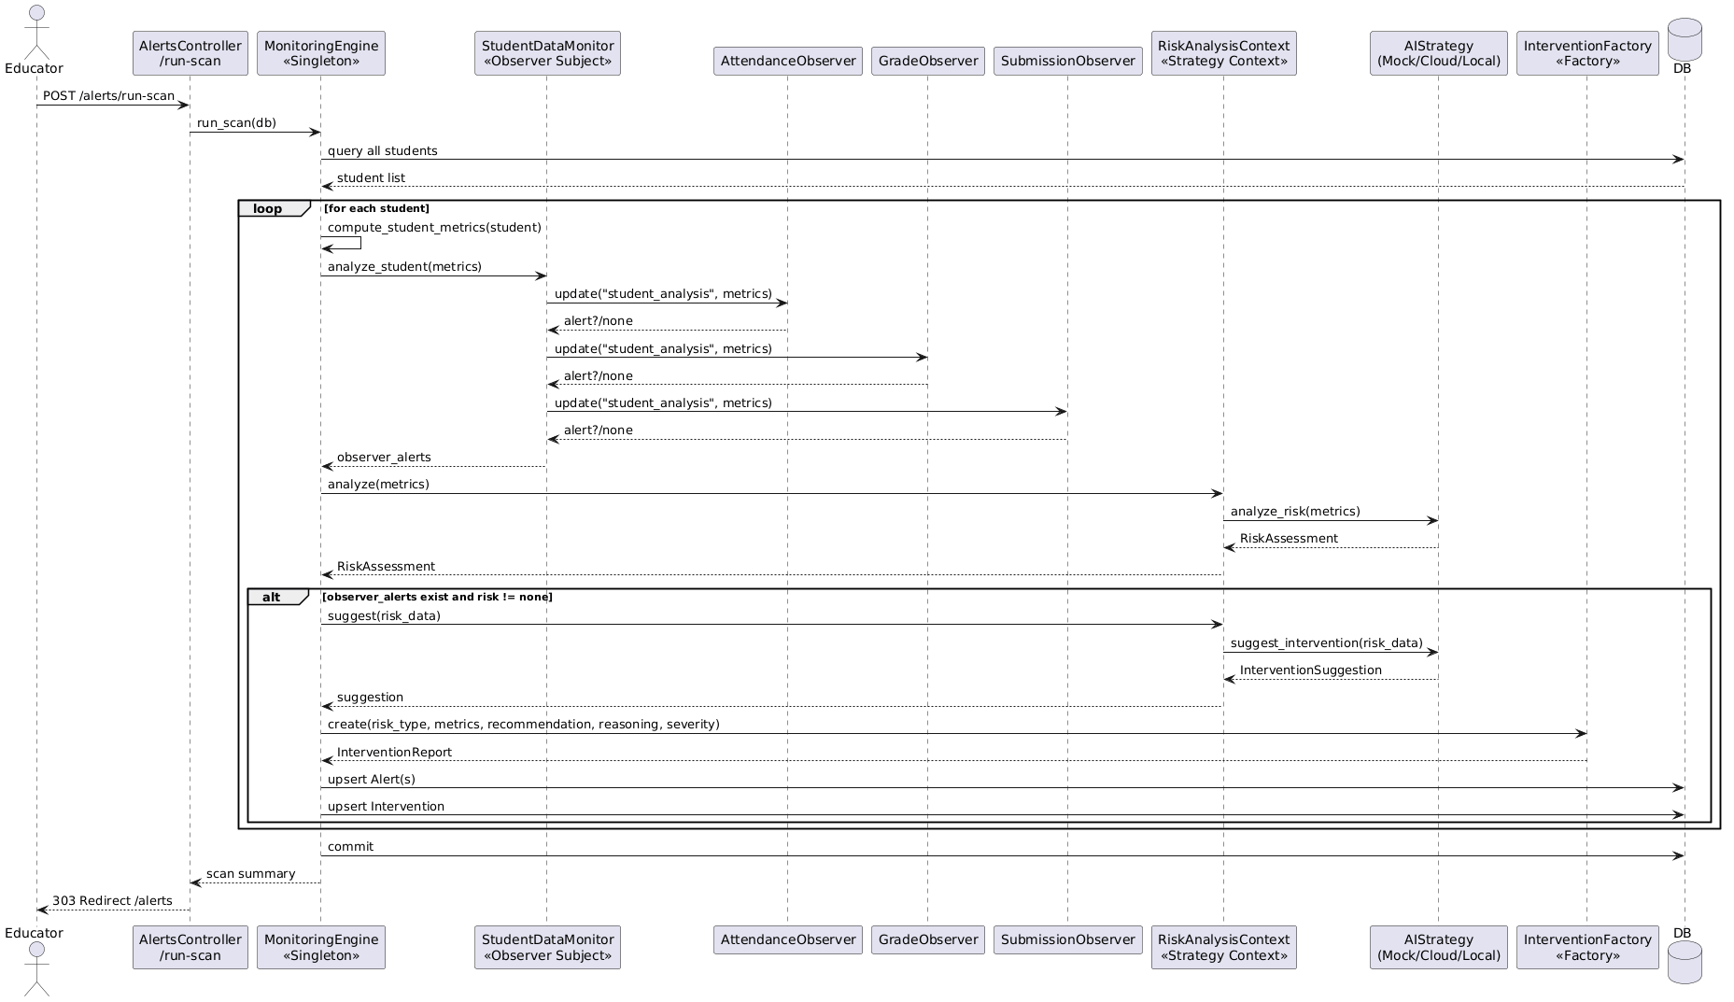

B.5 Activity Diagrams

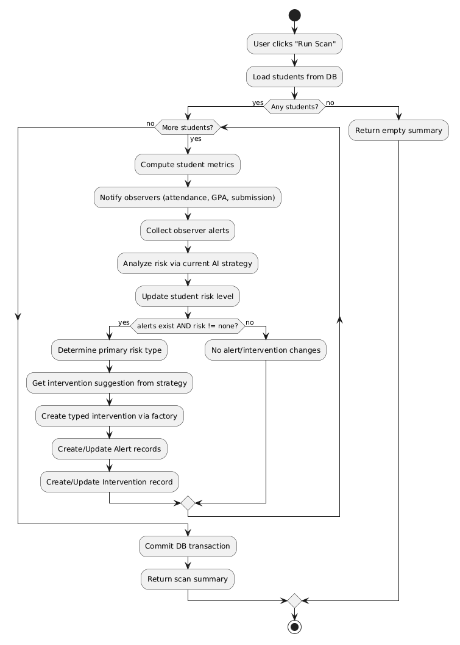

B.6 Architectural Diagram
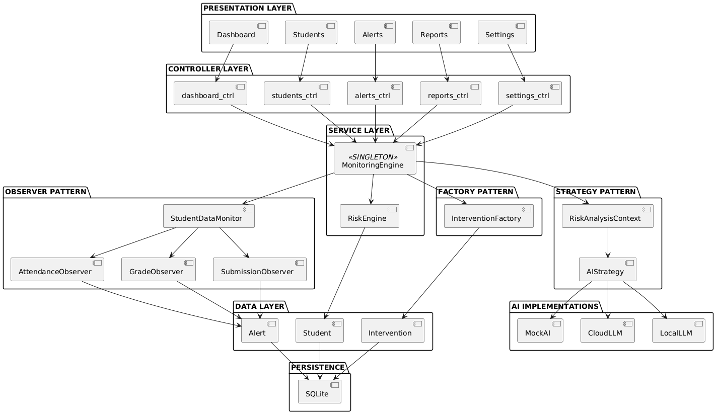

Appendix C: To Be Determined List
The following items require clarification or will be finalized during implementation:

C.1 Deployment and Hosting
- TBD-1: Final deployment environment (local development server vs. cloud hosting platform such as Render, Railway, or AWS)
- TBD-2: Production database selection (SQLite for demo vs. PostgreSQL/MySQL for multi-user deployment)
- TBD-3: Static asset hosting approach (local serving vs. CDN for Chart.js and other libraries)

C.3 Authentication and Access Control
- TBD-4: User authentication mechanism (session-based, token-based, or demo mode with no authentication)
- TBD-5: Role-based access control implementation (if multiple user types are supported beyond single academic user)

